

Practical File

Submitted to:

Manav Rachna International Institute of Research & Studies,

Faridabad (Haryana)

In partial fulfillment of

Masters of Computer Applications (MCA)

Session: 2020-2022

Under the supervision of Submitted By:

Name- kavita Arora Name -Mausam Mishra

# Faculty of Computer Applications

**Manav Rachna International Institute of Research& Studies**

Sector-43, Aravalli Hills Faridabad – 121001

|  |  |  |  |
| --- | --- | --- | --- |
| Index | | | |
| **S no.** | **Name Of Practical’s** | **Page No** | **Remarks** |
| 1. | Write a program to implement heading tag and Horizontal Line tag. | 1-2 |  |
| 2. | Design a web page using basic html tags. | 3-4 |  |
| 3. | Design the below web page with basic tags be creative. | 5-7 |  |
| 4. | Write a program to implement Ordered list , Unordered list, definition list. | 8-9 |  |
| 5. | Write a program to implement img tag. | 10 |  |
| 6. | Design your class timetable also put your college logo on top right side of the time table using table tag and img tag. | 11-141 |  |
| 7. | Write a program to implement table tag  using rowspan and colspan. | 15-16 |  |
| 8. | Write a program to create office timetable using all table tags. | 17-20 |  |
| 9. | Write a program to implement external linking in HTML. | 21-22 |  |
| 10. | Write a program to demonstrate internal  linking in html. | 23-24 |  |
| 11. | Write a program to implement frame tag. | 25 |  |
| 12. | Write a program to demonstrate different methods of implementing CSS. | 26-27 |  |
| 13. | Write a program to implement internal  CSS. | 28-29 |  |
| 14. | Write a program to implement inline CSS. | 30-31 |  |
| 15. | Write a program to implement external CSS. | 32-34 |  |
| 16. | Write a JavaScript program to swap 2  numbers. | 35-36 |  |
| 17. | Write a JavaScript program to add 2 numbers. | 37-38 |  |
| 18. | Write a JavaScript program to find  factorial of a number. | 39-40 |  |
| 19. | Write a JavaScript program to find roots of quadratic equation. | 41-42 |  |
| 20. | Write a JavaScript program to find greatest of 3 numbers. | 43-44 |  |
| 21. | Write a JavaScript program to sort an  array. | 45-46 |  |



|  |  |  |  |
| --- | --- | --- | --- |
| 22. | Write a JavaScript program to find largest element in array. | 47-48 |  |
| 23. | Write a JavaScript program to find the index of element in array. | 49 |  |
| 24. | Write a JavaScript program to grade of 5 students using array**.** | 50-51 |  |

# Q1. Write a program to implement heading tag and Horizontal Line tag.

**Input**

<html>

<head><title>Mausam</title></head>

<body bgcolor='red'>

<FONT color='blue'>

<center><b><i><u>MRIIRS

</b></i></u>

<br><br>

<b><i>Hello</b></i>

<hr color='blue'>

<h1>Hii this is h1</h1>

<hr color='blue'>

<h2>this is h2</h2>

</center>

</body>

</html>

# Output

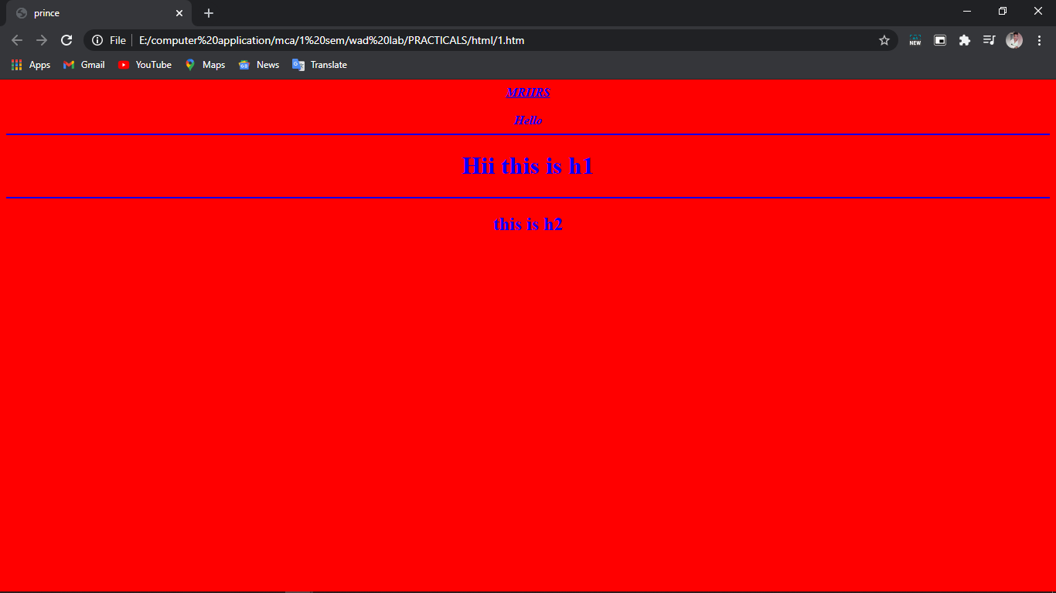

**Q2. Design a web page using basic html tags.**

# Input

<html>

<head><title>Mausam</title></head>

<body background=a.jpg>

<center>

<font color=White size=20><h1><b><i><u>Self Introduction</b></u></i></h1>

<hr height=75% width=75%></font></center>

<center>

<font color=White face='Comic Sans Ms'>

<h4>My name is Prince Breja.<br></h4> I am 20 years Old.<br>

I have completed my BCA from MRIIRS with aggregate of 92%.<BR> Currently I am Pursuing MCA from MRIIRS<BR>

<h4>Things I like to do:<br></h5> Bike Riding<br>

Coding<br> Cooking<br>

<h4>I love to play guitar</h4>

<h5>My area of Interests are :<br></h5> Data Science<br>

Artificial Intelligence<br>

<hr height=75% width=75%></font>

</body>

</html>

# Output

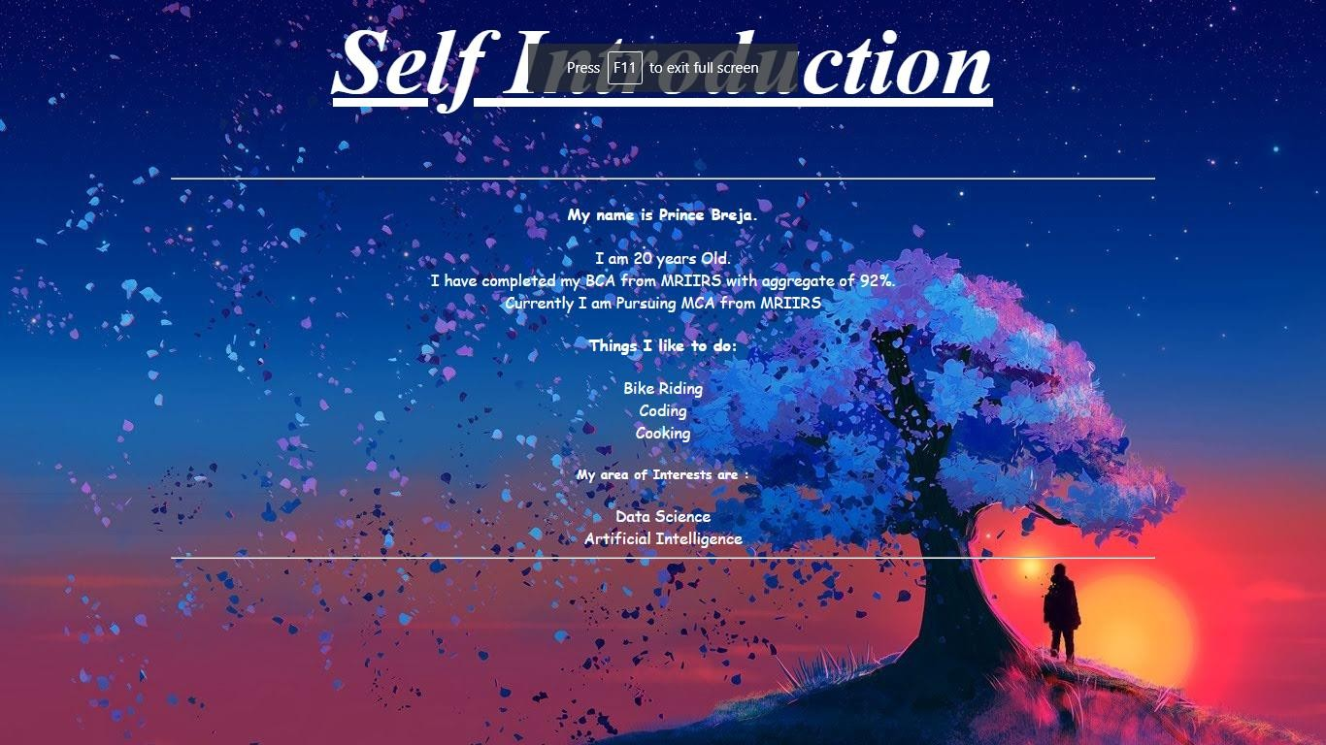

**Q3. Design the below web page with basic tags be creative.**



# Input

<html>

<head><title>Mausam font</title></head>

<body background=a.jpg>

<b><i>

<font face='Comic Sans MS' color=white size=56>

<h1><center>

Delta Engineering Pvt.Ltd.

</h1></font>

<hr color=white height=60% width=60%>

<br>

<font face='Comic Sans MS' color=white>

<center><h4> PROFILE</H4>

<p>

Delta Engineering Pvt ltd is a specialist manuacturer of wire and wire products.DEPL<br> established in Mumbai,India is ideally located for shipments

to any part of the world.The main <br>items of manufacture, in collaboration with Gulf Fencing Industry (GFI) inlcude protector of gabion<br>

and protector fencing system</p>

<p>

Protector fencing systems after a wwider range of solutions of all security problems on any terrain and <br>

under extreme climatic conditions. The protector fencing system has been used extensively in <br> Europe,America and the Far East, and this has helped formulate a package especially suited to <br> Middle East requirements.</p>

<p>

DEPL is equipped to offer comprehensive packages including design, material and installation.

<hr color=white height=60% width=60%>

</body>

</html>

# Output

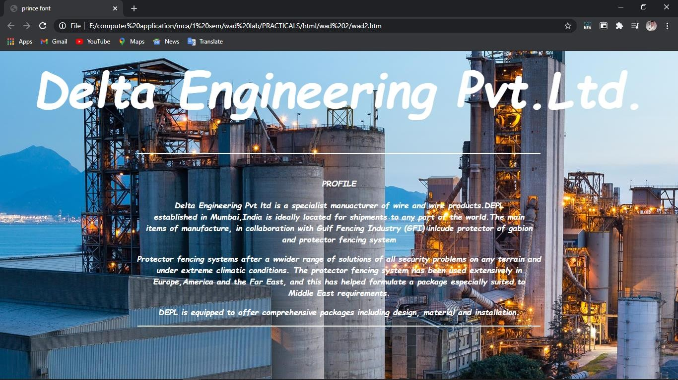

**Q4. Write a program to implement Ordered list , Unordered list, definition list.**

# Input

<html>

<head><title>Mausam</title></head>

<body>

<b>//Example of unordered list//</b>

<ul type=filledcircle>

<li>Sportstar</li>

<li>Business Week</li>

<li>Time</li>

</ul>

<b>//Example of ordered list//</b>

<ol type=i start=4>

<li>Sportstar</li>

<li>Business Week</li>

<li>Time</li>

</ol>

<b>//Example of definition list//</b>

<dt>sports magazine

<dd> sportstar

<dt>business magazine

<dd>business week

</body>

</html>

# Output

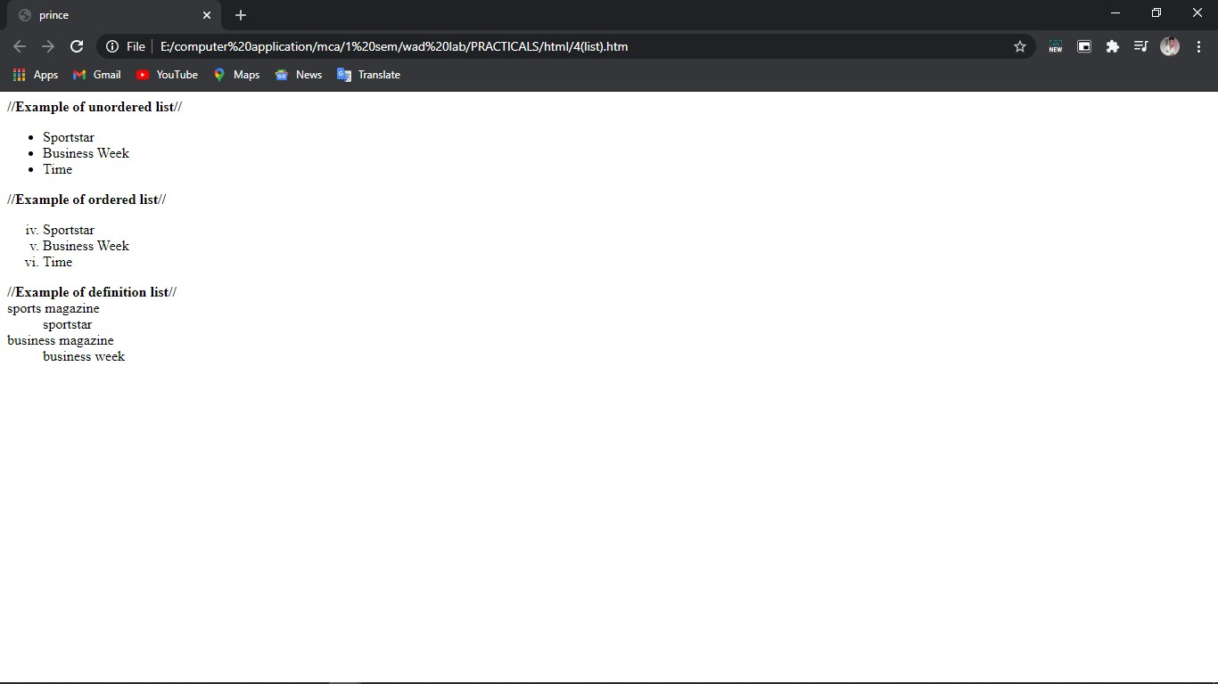

**Q5. Write a program to implement img tag.**

# Input

<html>

<head><title> prince</title>

</head>

<body>

<img src="d.jpg" height=50% width=50%>

</body>

</html>

# Output

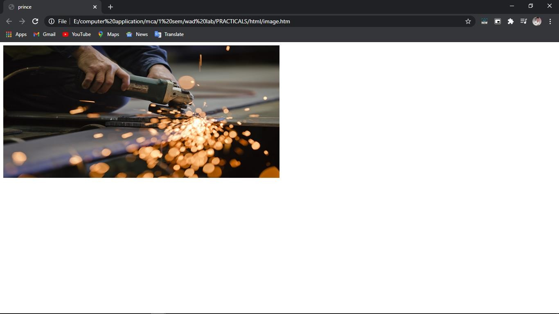

**Q6. Design your class timetable also put your college logo on top right side of the time table using table tag and img tag.**

# Input

<html>

<head><title>mca tt</title></head>

<body>

<img src=mr.png align=right height=10% width=10%>

<table height=90% width=100% border=2>

<CAPTION>MRIIRS MCA SEM-1</CAPTION>

<tr ALIGN=CENTER>

<td>period</td>

<td>1</td>

<td>2</td>

<td>3</td>

<td>4</td>

</tr>

<tr ALIGN=CENTER>

<td>Days</td>

<td></td>

<td></td>

<td></td>

<td></td>

</tr>

<tr ALIGN=CENTER>

<td>MONDAY</td>

<td BGCOLOR=LIGHTGREY>DS(9:00-10:30)<BR>(SS)</TD>

<TD BGCOLOR=LIGHTBLUE>MATHS(10:45-11:45)<BR>(PG)</TD>

<TD BGCOLOR=PURPLE>RIC(12:00-12:30)<BR>(RA)</TD>

<TD BGCOLOR=YELLOW>FCP(12:45-1:45)<BR>(AP)</TD>

</TR>

<TR ALIGN=CENTER>

<TD>TUESDAY</TD>

<Td BGCOLOR=YELLOW>FCP(9:00-10:00)<BR>(AJ)</TD>

<TD BGCOLOR=ORANGE>WAD(10:15-11:45)<BR>(PG)</TD>

<TD BGCOLOR=LIGHTGREEN>LAST(12:00-2:00)<BR>(SP)</TD>

<TD></TD>

</TR>

<TR ALIGN=CENTER>

<TD>WEDNESDAY</TD>

<TD BGCOLOR=LIGHTBLUE>MATHS(9:00-10:00)<BR>(DR SAKET)</TD>

<TD BGCOLOR=PINK>PYTHON LAB(10:15-11:15)<BR>(AP)</TD>

<TD BGCOLOR=ORANGE>WAD(11:30-1:00)<BR>(PG)</TD>

<TD BGCOLOR=ORANGE>JAVA(1:00-2:30)<BR>(PS)</TD>

</TR>

<TR ALIGN=CENTER>

<TD>THURSDAY</TD>

<TD BGCOLOR=ORANGE>JAVA(9:00-10:30)<BR>(PS)</TD>

<TD BGCOLOR=LIGHTGREY>DS LAB(10:45-11:45)<BR>(SS)</TD>

<TD BGCOLOR=ORANGE>WAD LAB(12:00-1:00)<BR>(PG)</TD>

<TD></TD>

</TR>

<TR ALIGN=CENTER>

<TD>FRIDAY</TD>

<TD BGCOLOR=LIGHTGREY>DS(9:00-10:30)<BR>(SS)</TD>

<TD BGCOLOR=ORANGE>JAVA LAB(10:45-11:45)<BR>(PS)</TD>

<TD BGCOLOR=LIGHTGREEN>LAST(12:00-2:00)<BR>(SP)</TD>

<TD></TD>

</TR>

</table>

</body>

</html>

# Output

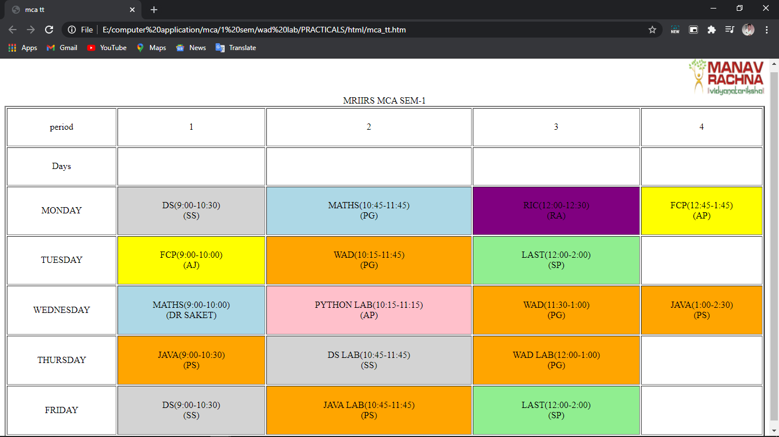

**Q 7. Write a program to implement table tag using rowspan and colspan.**

# Input

<HTML>

<HEAD><TITLE>Mausam</TITLE></HEAD>

<BODY>

<TABLE border=2 height=10% width=25% align=center>

<center>

<TR>

<td align=center>1</td>

<td align=center>2</td>

<td colspan="3" align=center>3</td>

</tr>

<tr>

<td rowspan="2" align=center>4</td>

<td align=center>5</td>

<td colspan="2" align=center>6</td>

<td align=center>7</td>

</tr>

<tr>

<td colspan="2" align=center>8</td>

<td colspan="2" align=center>9</td>

</tr>

<tr>

<td align=center>10</td>

<td align=center>11</td>

<td rowspan="2" align=center>12</td>

<td rowspan="2" align=center>13</td>

<td rowspan="2" align=center>14</td>

</tr>

<tr>

<td align=center>15</td>

<td align=center>16</td>

</tr>

</table>

</body>

</html>

# Output

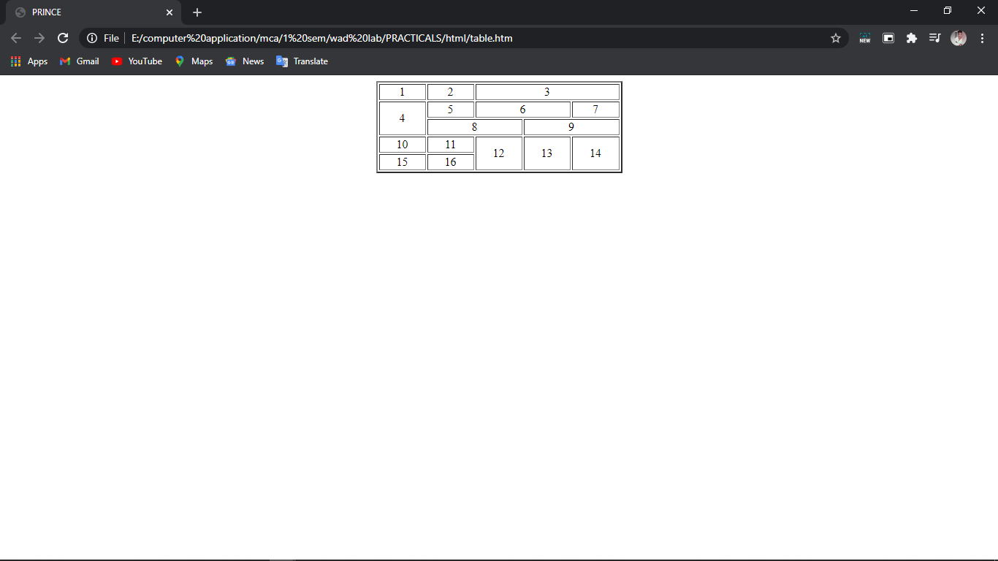

**Q8. Write a program to create office timetable using all table tags.**

Input

Mausam</title></head>

<body>

<html>

<head>

<title>

<table width=100% height=100% border=6>

<caption fontcolor=pink>Jan's Spring Term 2020 Afternoon Schedule</caption>

<tr>

<th></th>

<th>Monday</th>

<th>Tuesday</th>

<th>Wednesday</th>

<th>Thursday</th>

<th>Friday</th>

</tr>

<tr align=center>

<td>1:00</td>

<td rowspan=2 bgcolor=orange>Office</td>

<td></td>

<td rowspan=2 bgcolor=orange>Office</td>

<td rowspan=8 bgcolor=orange>Office Hours By Appt</td>

<td rowspan=2 bgcolor=orange>Office</td>

</tr>

<tr align=center>

<td>1:30</td>

<td bgcolor=Grey rowspan=2>Dept Meeting</td>

</tr>

<tr align=center>

<td>2:00</td>

<td rowspan=3 bgcolor=lightgreen>MAT 108</td>

<td rowspan=3 bgcolor=lightgreen>MAT 108</td>

<td rowspan=3 bgcolor=lightgreen>MAT 108</td>

</tr>

<tr align=center>

<td>2:30</td>

<td></td>

</tr>

<tr align=center>

<td>3:00</td>

<td bgcolor=lightgrey rowspan=3>EC Meeting</td>

</tr>

<tr align=center>

<td>3:30</td>

<td bgcolor=pink rowspan=3>CSC 205</td>

<td bgcolor=pink rowspan=3>CSC 205</td>

<td bgcolor=pink rowspan=3>CSC 205</td>

</tr>

<tr align=center>

<td>4:00</td>

</tr>

<tr align=center>

<td>4:30</td>

<td></td>

</tr>

</table>

</body>

</html>

# Output

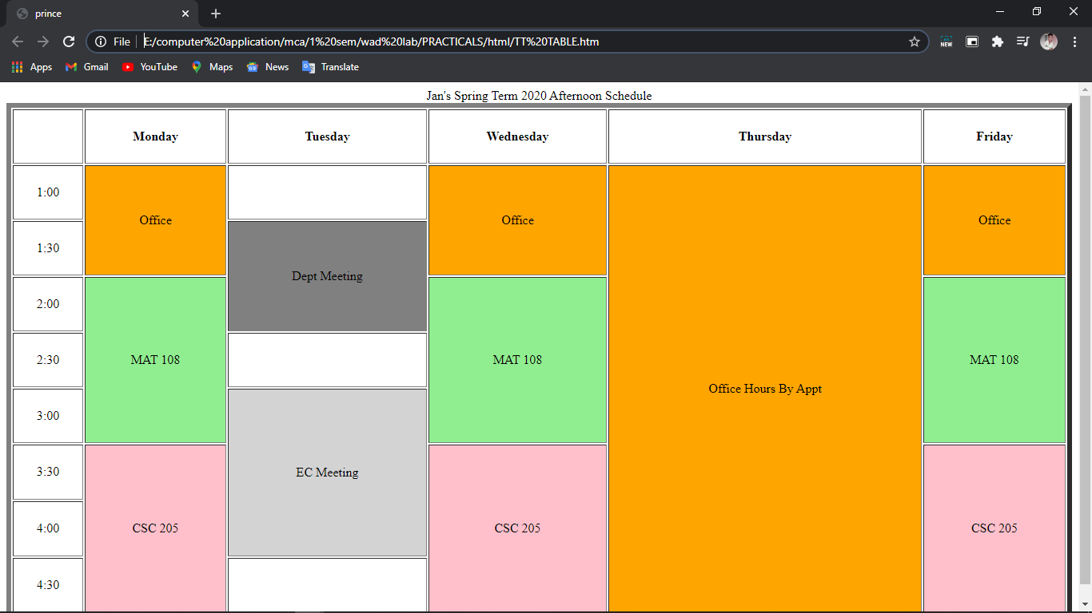

**Q9. Write a program to implement external linking in HTML.**

# Input

<html>

<body>

<h1>Search Engines</h1>

<a href="[http://www.google.com](http://www.google.com/)"> Google!

</a>

<br /><br />

<a href="[http://www.yahoo.com](http://www.yahoo.com/)"> Yahoo!

</a>

<br /><br />

<a href="[http://www.bing.com](http://www.bing.com/)"> Bing!

</a>

<br /><br />

<a href="[http://www.altavista.com](http://www.altavista.com/)"> Altavista!

</a>

</a>

</body>

</html>

# Output

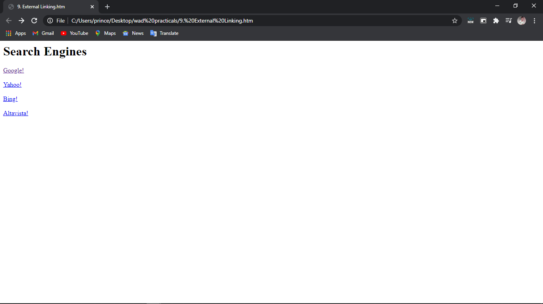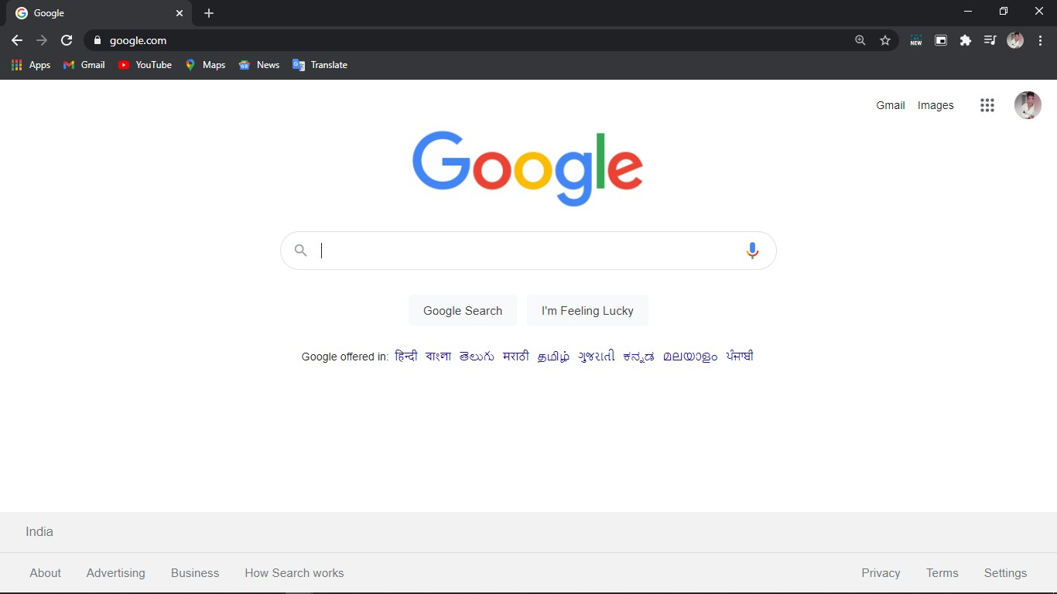

**Q10. Write a program to demonstrate internal linking in html.**

# Input

<html>

<body>

<a name="top">The top of the page</a>

<br /><br />

<a href="#bottom">Jump to the bottom of the page</a>

<p>hello</p>

<p>Hello</p>

<p>Hello</p>

<p>Hello</p>

<p>Hello</p>

<p>Hello</p>

<p>Hello</p>

<p>Hello</p>

<p>Hello</p>

<p>Hello</p>

<p>Hello</p>

<p>Hello</p>

<p>Hello</p>

<p>Hello</p>

<p>Hello</p>

<p>Hello</p>

<p>Hello</p>

<p>Hello</p>

<p>Hello</p>

<p>text</p>

<a href="#top">Jump to the top of the page</a>

<br /><br />

<a name="bottom">The bottom of the page</a>

</body>

</html>

# Output

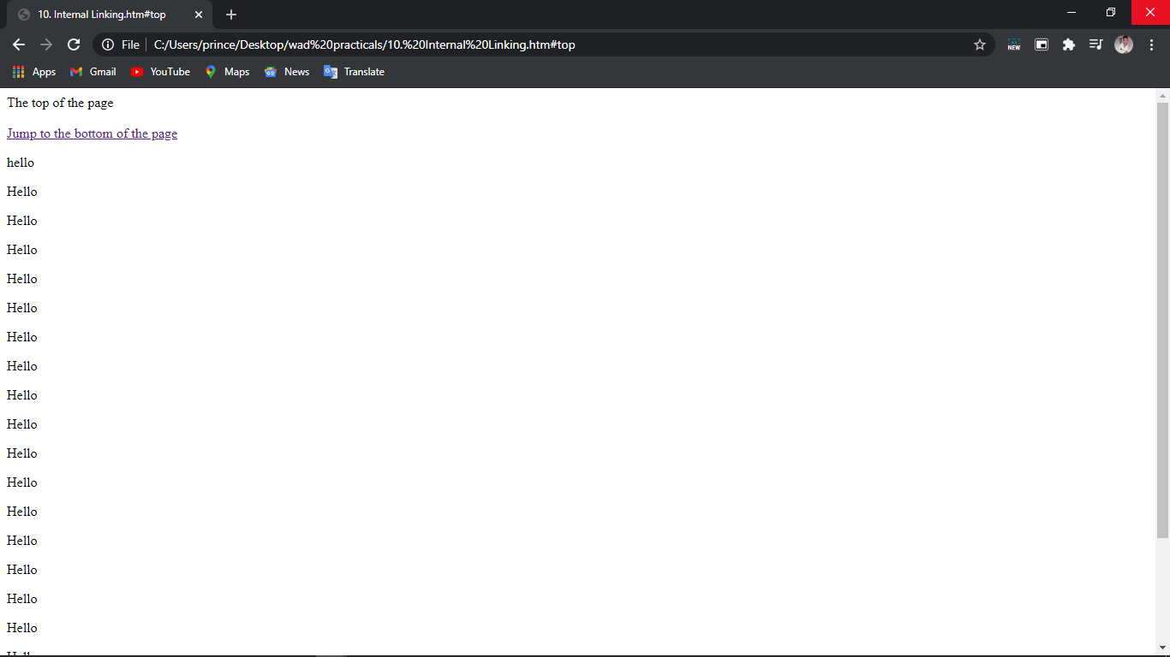

**Q11. Write a program to implement frame tag.**

# Input

<HTML>

<HEAD>

<TITLE>frames</TITLE>

</HEAD>

<frameset cols="30%, 70%" bordercolor="blue" noresize="noresize">

<frameset rows="100, 200" bordercolor="red">

<frame name="frame-1" src="page1.html">

<frame name="frame-2" src="page2.html">

</frameset>

<frame name="frame3" src="page3.html">

<noframes>

<p> This document contains frames content. You browser does not support it. </p>

</noframes>

</frameset>

</HTML>

# Output

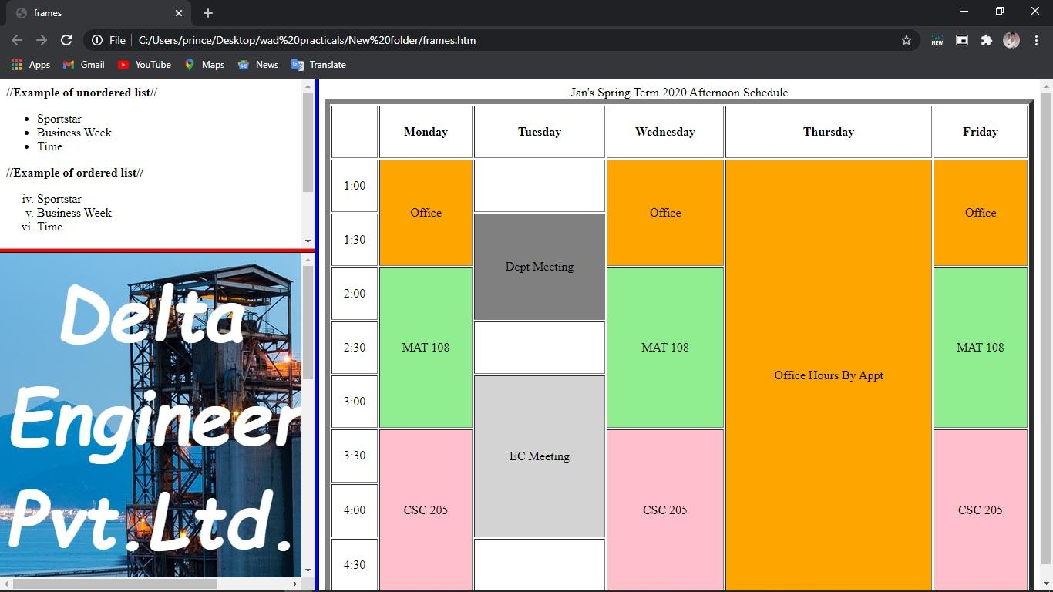

**Q12. Write a program to demonstrate different methods of implementing CSS.**

# Input

<html>

<head><title> Mausam</title>

<link rel="stylesheet" href="styles.css">

<style>

p {color: white;}

</style>

<body>

<h1 style="color:white;">h1 tag using inline css</h1>

<p>this tag is styled by internal css</p>

</body>

</html>

# Styles.css

body {

background-image: url("a.jpg"); background-color: blue;

}

# Output

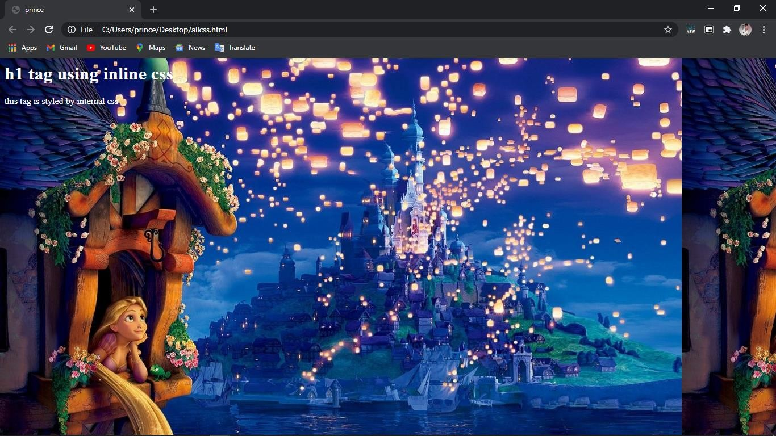

**Q13. Write a program to implement internal CSS.**

# Input

<html>

<head>

<style> body {

background-image: url("a.jpg"); background-color: #cccccc;

}

h1{ color:white;

text-align: center;} img {

border-radius: 8px;

}

p{

font: italic small-caps bold 12px/30px Georgia, serif; color:white;

text-align: left;

}

</style>

</head>

<body>

<h1>Anime</h1>

<hr color=white width=75% height=75%>

<img src="b.png" align=right height=20% width=10% >

<p><u><b>Crayon Shin-chan</b> </u>first appeared in a Japanese weekly magazine called Weekly Manga Action, which is published by Futabasha. The anime Crayon Shin-chan has been on TV Asahi since April 13, 1992, and on several television networks, worldwide.</p>

<hr color=white width=75% height=75%>

<img src="c.png" align=left height=20% width=10% >

<p><u><b>Ryoutsu</b></u> is a middle-aged man of a rather short but robust stature, who sports a crew-cut hairstyle and noticeably thick bouts of body hair, plus visible stubble. His similarly extra thick and curvy 'm'-shaped unibrow is his most famed asset, and serves as the signature image associated with Kochikame in general due to its uniqueness and familiarity with local Japanese fans.

</p>

<hr color=white width=75% height=75%>

</body>

</html>

# Output

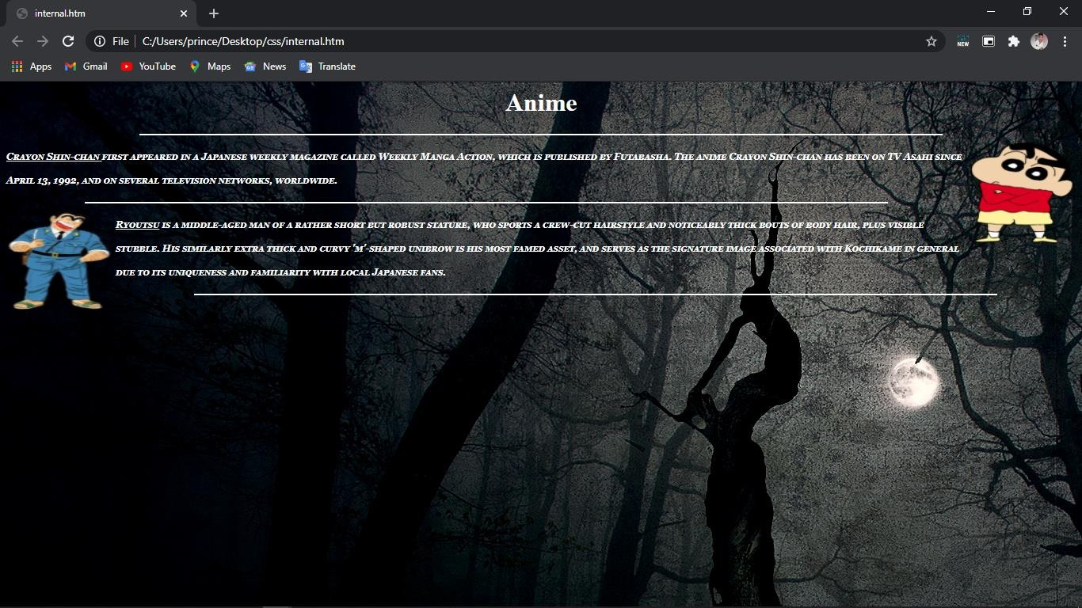

**Q14. Write a program to implement inline CSS.**

# Input

<html>

<head>

</head>

<body style=background-image:url("a.jpg");>

<h1 style=color:white;text-align:center;> Anime

</h1>

<hr color=white width=75% height=75%>

<img src="b.png" align=right height=20% width=10% >

<p style="font:italic small-caps bold 12px/30px Georgia, serif;color:white;text-align:left;">

<u><b>Crayon Shin-chan</b> </u>first appeared in a Japanese weekly magazine called Weekly Manga Action, which is published by Futabasha. The anime Crayon Shin-chan has been on TV Asahi since April 13, 1992, and on several television networks, worldwide.</p>

<hr color=white width=75% height=75%>

<img src="c.png" align=left height=20% width=10% >

<p style="font:italic small-caps bold 12px/30px Georgia, serif;color:white;text-align:left;">

<u><b>Ryoutsu</b></u> is a middle-aged man of a rather short but robust stature, who sports a crew-cut hairstyle and noticeably thick bouts of body hair, plus visible stubble. His similarly extra thick and curvy 'm'-shaped unibrow is his most famed asset, and serves as the signature image associated with Kochikame in general due to its uniqueness and familiarity with local Japanese fans.

</p>

<hr color=white width=75% height=75%>

</body>

</html>

# Output



**Q15. Write a program to implement external CSS.**

# Input

<html>

<head>

<link rel="stylesheet" href="style.css">

</head>

<body>

<h1>Anime</h1>

<hr color=white width=75% height=75%>

<img src="b.png" align=right height=20% width=10% >

<p><u><b>Crayon Shin-chan</b> </u>first appeared in a Japanese weekly magazine called Weekly Manga Action, which is published by Futabasha. The anime Crayon Shin-chan has been on TV Asahi since April 13, 1992, and on several television networks, worldwide.</p>

<hr color=white width=75% height=75%>

<img src="c.png" align=left height=20% width=10% >

<p><u><b>Ryoutsu</b></u> is a middle-aged man of a rather short but robust stature, who sports a crew-cut hairstyle and noticeably thick bouts of body hair, plus visible stubble. His similarly extra thick and curvy 'm'-shaped unibrow is his most famed asset, and serves as the signature image associated with Kochikame in general due to its uniqueness and familiarity with local Japanese fans.

</p>

<hr color=white width=75% height=75%>

</body>

</html>

***Style.css***

body {

background-image: url("a.jpg"); background-color: #cccccc;

}

h1{color:white; text-align: center;} img {

border-radius: 8px;

}

p{

font: italic small-caps bold 12px/30px Georgia, serif; color:white;text-align: left;

}

# Output



**Q16. Write a JavaScript program to swap 2 numbers.**

# Input

<html>

<head>

<script language ="JavaScript">

var num1=prompt("Enter the 1st number "); var num2 = prompt("enter the 2nd number "); var num3 =num1;

num1=num2; num2=num3;

</script>

</head>

<body>

<script language = "JavaScript">

document.write("<h1> First no "+ num1 + " second number "+ num2 +"</h1>");

</script>

</body>

</html>

# Output

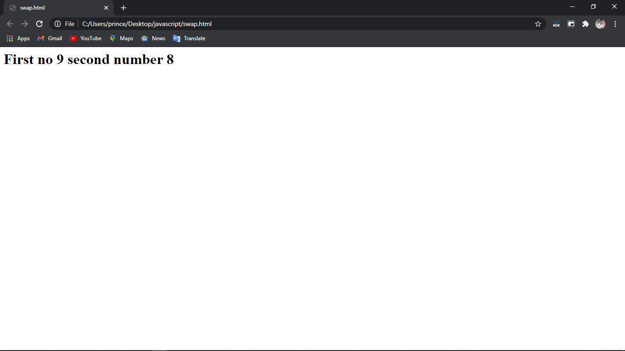

**Q17. Write a JavaScript program to add 2 numbers.**

# Input

<html>

<head>

<script language ="JavaScript">

var num1=prompt("Enter the 1st number "); var num2 = prompt("enter the 2nd number "); x=parseInt(num1)

y=parseInt(num2) var num3 =x+y;

</script>

</head>

<body>

<script language = "JavaScript">

document.write("<h1> result of addition"+num1+ "+" +num2+ "=" +num3+"</h1>");

</script>

</body>

</html>

# Output

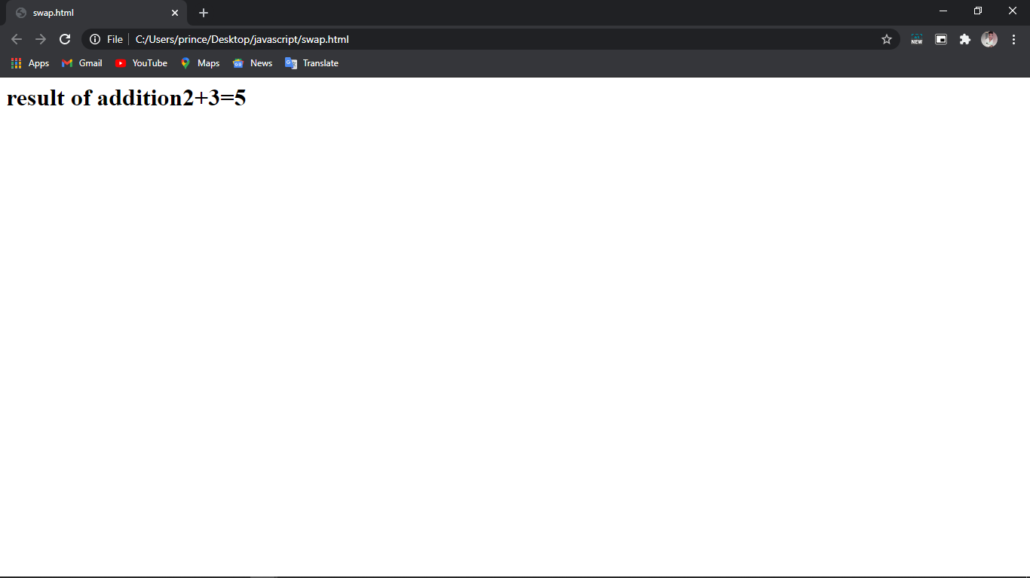

**Q18. Write a JavaScript program to find factorial of a number.**

# Input

<html>

<head>

<script> function show(){ var i, no, fact; fact=1;

no=Number(document.getElementById("num").value); for(i=1; i<=no; i++)

{

fact= fact*i;

}

document.getElementById("answer").value= fact;

}

</script>

</head>

<body><font color=orange >

<h1><center>Factorial Of A number</h1> Enter Num: <input id="num">

<button onclick="show()">Factorial</button>

<input id="answer">

</body>

</html>

# Output

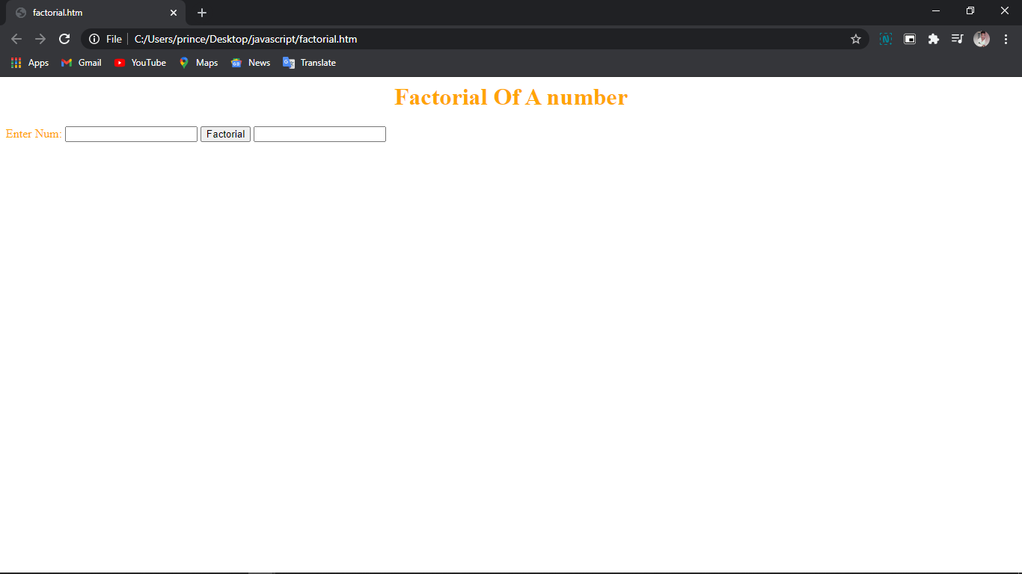

**Q19. Write a JavaScript program to find roots of quadratic equation.**

# Input

<HTML>

<head>

<title>Quadratic Equation</title>

<script type="text/JavaScript">

var a = prompt("Enter value of a","1"); var b = prompt("Enter value of b","4"); var c = prompt("Enter value of c","4");

var root_part = Math.sqrt(b * b - 4 * a * c); var denom = 2 * a;

var root1 = ( -b + root_part ) / denom; var root2 = ( -b - root_part ) / denom;

</script>

<body>

<center><h1>Quadratic Roots

</h1>

<script>

document.write("1st root: "+root1+"<br />"); document.write("2nd root: "+root2+"<br />");

</script>

</HEAD></HTML>

# Output

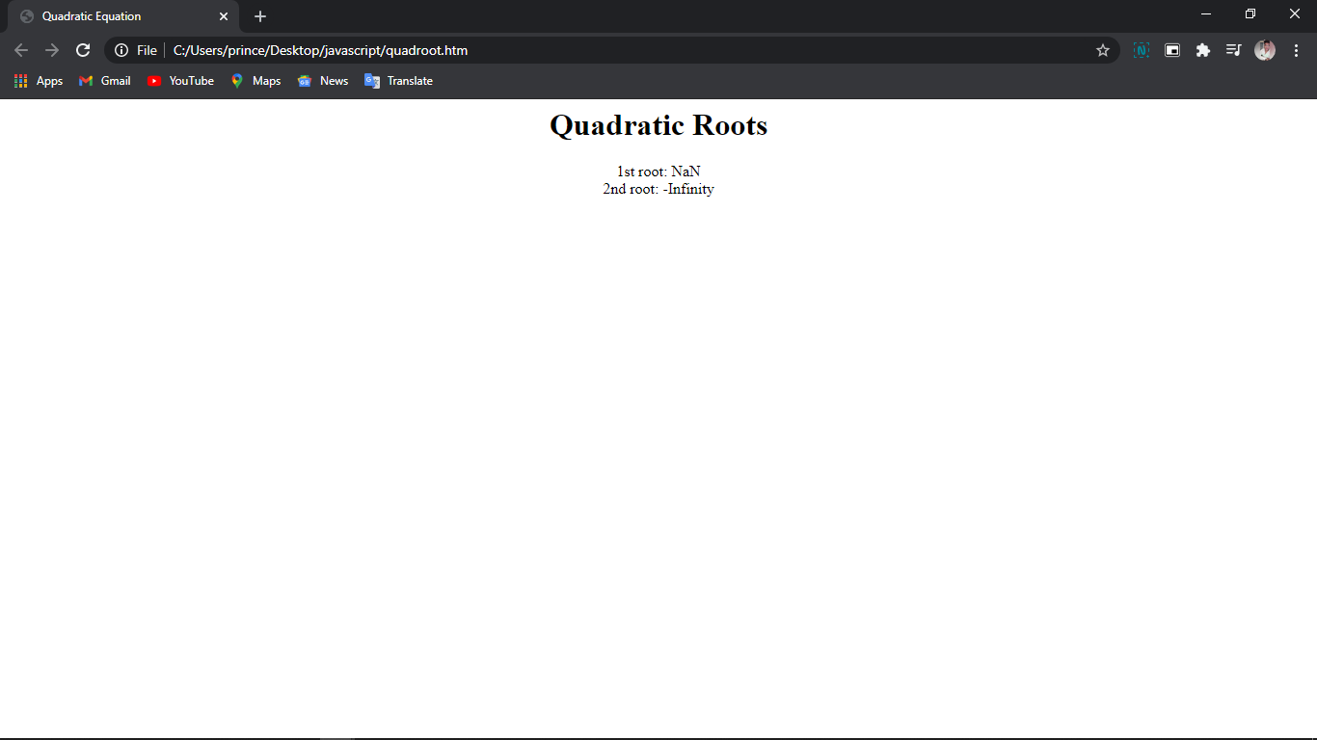

**Q20. Write a JavaScript program to find greatest of 3 numbers.**

# Input

<html>

<head>

<center><font color=magenta type="Comic Sans Ms">

<h1>Greatest Among Three Numbers</h1>

</head>

<body>

<script>

var a = prompt("enter value for a"); var b = prompt("enter value for b"); var c = prompt("enter value for c"); if (a>b && a>c)

{

document.write("<b>A is greater</b>");

}

if (b>a && b>c)

{

document.write("<b>B is greater</b>");

}

else

{

document.write("<b>C is greater</b>");

}

</script>

</body>

</html>

# Output

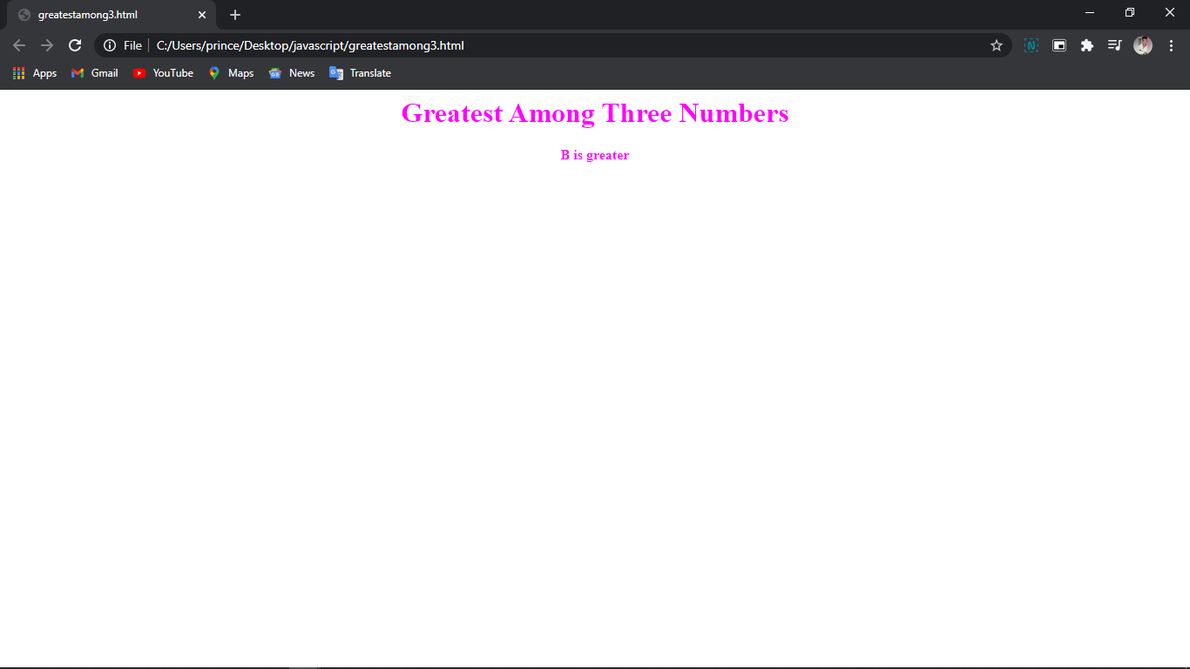

**Q21. Write a JavaScript program to sort an array.**

# Input

<!DOCTYPE html>

<html>

<head>

<title></title></head>

<body>

<script>

var arr1=[8,7,6,5,4,3,2,1];

document.write("<h1>"+"<center>"+"array sorting program"+"</h1>"+"</center>") document.write("<h1>"+"<center>"+"array before sort"+" " +arr1+"</h1></center>")

var arr2=[];

var min=arr1[0]; var pos;

var max=arr1[0];

for (i=0; i<arr1.length; i++)

{

if (max<arr1[i]) max=arr1[i];

}

for (var i=0;i<arr1.length;i++)

{

for (var j=0;j<arr1.length;j++)

{

if (arr1[j]!="x")

{

if (min>arr1[j])

{

min=arr1[j];

pos=j;

}

}

}

arr2[i]=min; arr1[pos]="x"; min=max;

}

document.write("<br>");

document.write("<h1>"+"<center>"+"array after sort"+" "+arr2+"</h1></center>")

</script>

</body>

</body>

</html>

# Output

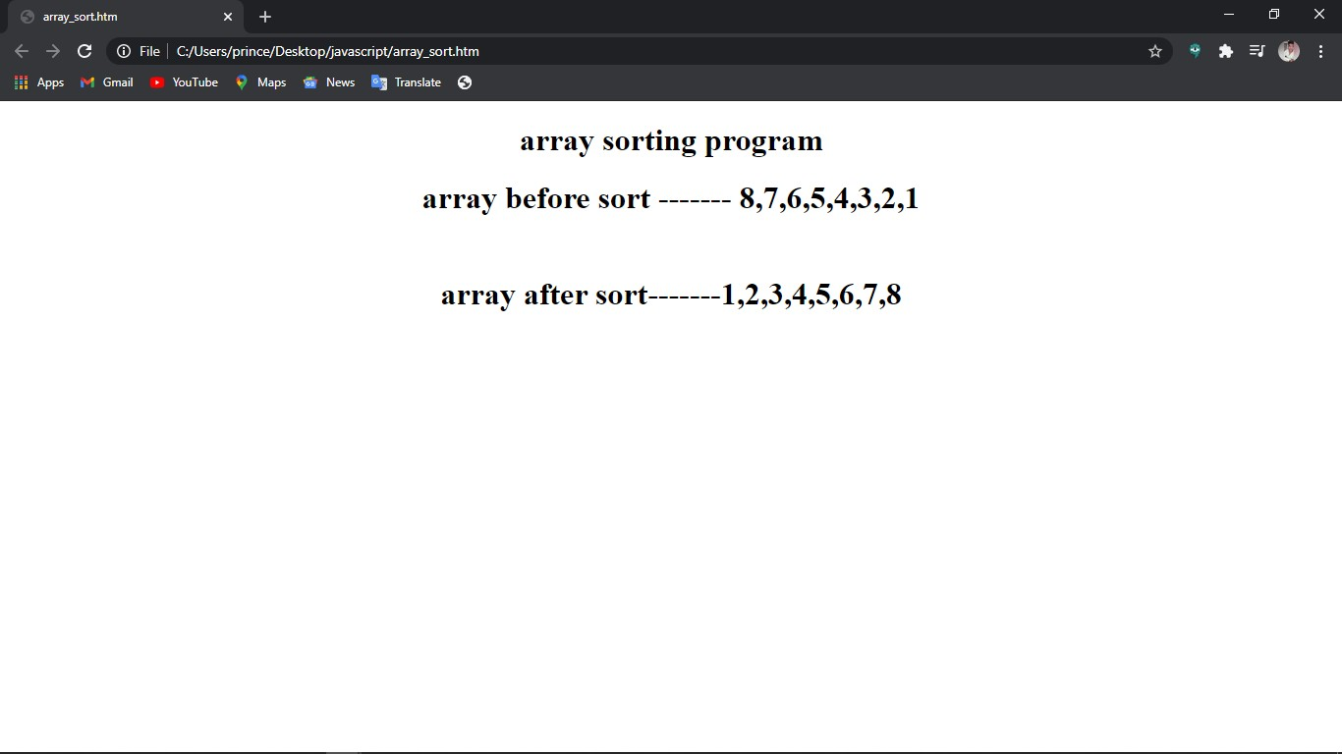

**Q22. Write a JavaScript program to find largest element in array.**

# Input

<html>

<head></head>

<body>

<script>

var array = [3 , 6, 2, 56, 32, 5, 89, 32];

document.write("<h1>"+"<center>"+"wap to find largest element in array"+"</h1>"+"</center>"); document.write("<h1>"+"<center>"+"Array---"+array+"</h1>"+"</center>");

var largest= 0;

for (i=0; i<=largest;i++){ if (array[i]>largest) {

var largest=array[i];

}

}

document.write("<h1>"+"<center>"+"largest element---"+largest+"</h1>"+"</center>");

</script>

</head>

</html>

# Output

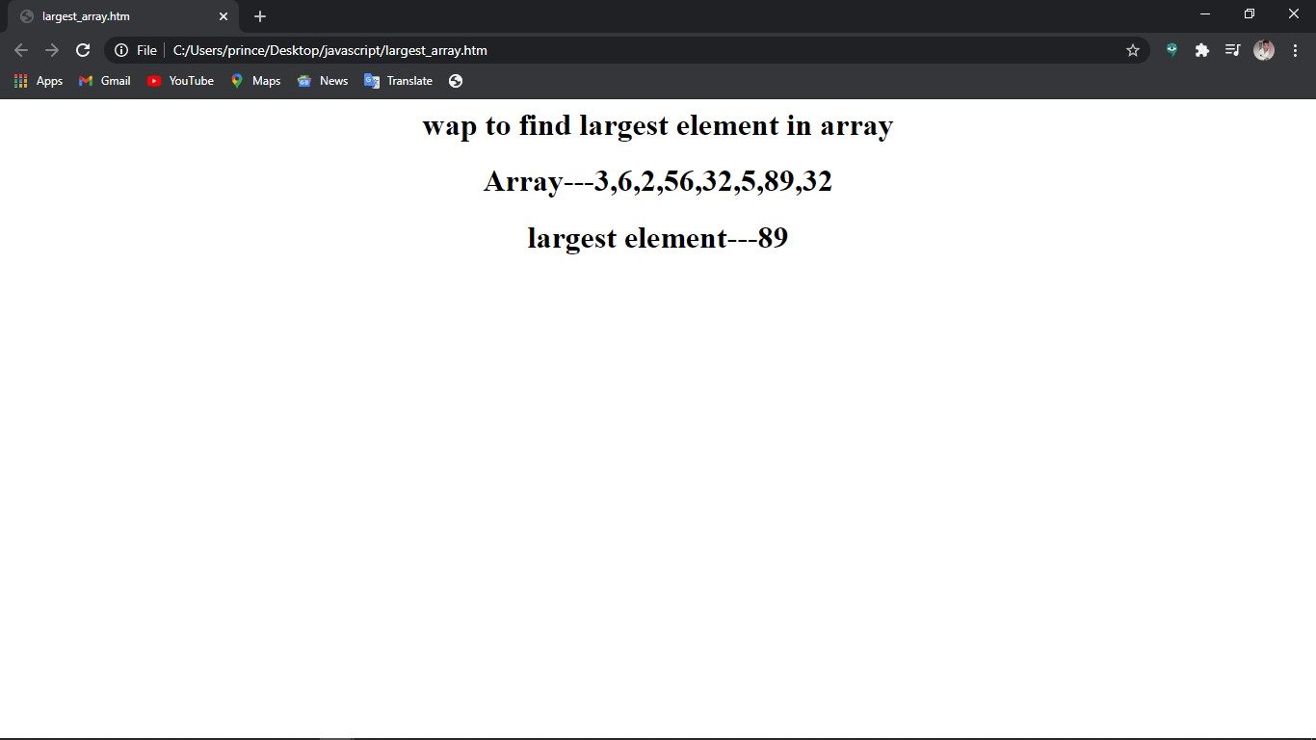

**Q23. Write a JavaScript program to find the index of element in array.**

# Input

<html>

<head></head>

<body>

<script>

var array = [3 , 6, 2, 56, 32, 5, 89, 32];

document.write("<h1>"+"<center>"+"wap to find position of element in array"+"</h1>"+"</center>");

document.write("<h1>"+"<center>"+"Array---"+array+"</h1>"+"</center>"); var a = array.indexOf(32);

document.write("<h1>"+"<center>"+"Index of element---"+a+"</h1>"+"</center>");

</script>

</head>

</html>

# Output

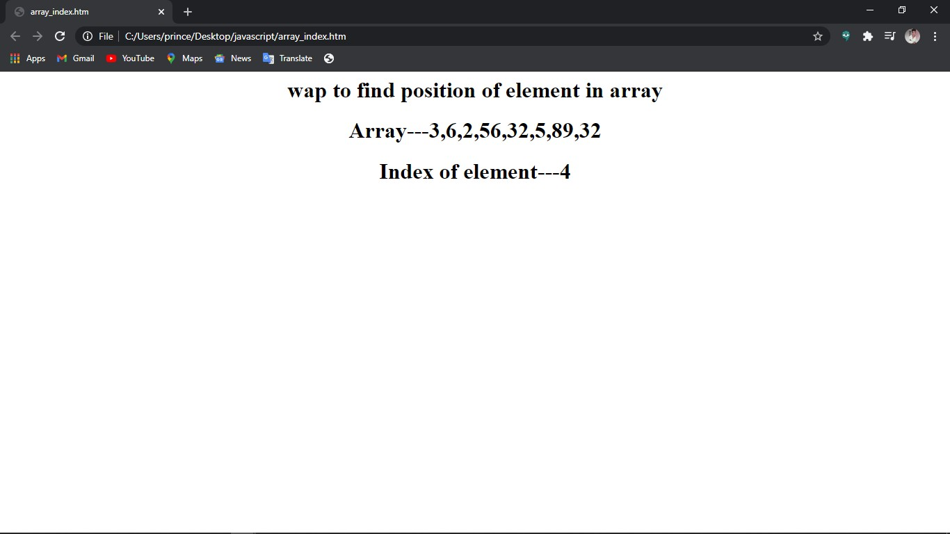

**Q24. Write a JavaScript program to grade of 5 students using array.**

# Input

<html>

<head></head>

<body>

<script>

var students = [['prince', 100], ['krishna', 77], ['rohan', 88], ['vishal', 95], ['shubham', 68]];

var Avgmarks = 0;

for (var i=0; i < students.length; i++) { Avgmarks += students[i][1];

var avg = (Avgmarks/students.length);

}

document.write("Average grade: " + (Avgmarks)/students.length);

if (avg < 60){ document.write("Grade : F");

}

else if (avg < 70) { document.write("Grade : D");

}

else if (avg < 80)

{

document.write("Grade : C");

} else if (avg < 90) { document.write("Grade : B");

} else if (avg < 100) {

document.write("Grade : A");

}</script>

</body>

</html>

# Output

